Paul Kafka

HW 1

Submitted: 9/9/13

Due: 9/11/13

**BDF Top Level**

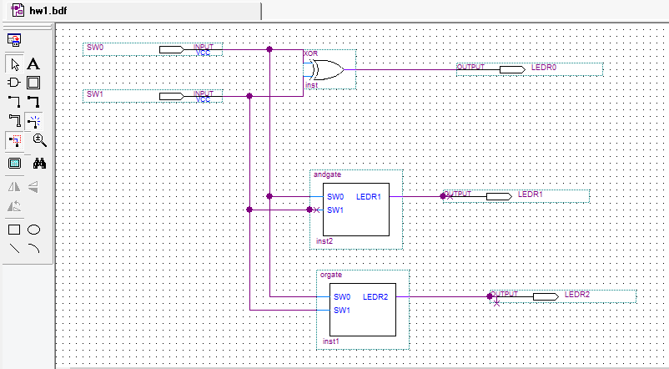

**Verilog Source (orgate.v)**

module orgate

(

input SW0, SW1,

output LEDR2

);

assign LEDR2 = SW0 | SW1;

endmodule

**VHDL Source (andgate.vhd)**

library ieee;

use ieee.std_logic_1164.all;

use ieee.numeric_std.all;

entity andgate is

port

(

SW0, SW1 : in std_logic;

LEDR1 : out std_logic

);

end entity;

architecture rtl of andgate is

begin

LEDR1 <= SW0 AND SW1;

end rtl;

**Simulation**